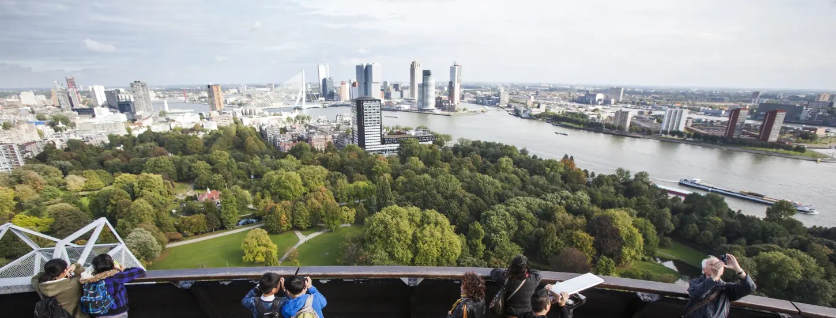
Doing justice to diversity and inclusion
in research grant submissions

Seeking out diversity, and being inclusive of different people and perspectives, sets us up for more impactful research proposals, stronger projects and better science.
Embracing and welcoming diversity is not only a hallmark of the social sciences, but also of Rotterdam as the diverse city where much of our research takes place. Committing in our research proposals to including and understanding a diversity of lived experiences makes for better and more robust and societally-relevant research proposals, and increases the positive impact we can make. That is why funders are increasingly calling on researchers to do justice to diversity and inclusion in their research proposals.
At ESSB, diversity and inclusion are verbs: something we do, normalise and embed in the design of our research projects and grant submissions. In this way, we commit to increasing our knowledge about how the social and behavioural issues we study affect more people in society. Diversity and inclusion are not an ad hoc consideration to comply with, nor a box to tick, but central to modern science.
We want to help researchers be more inclusive in their proposals for research funding. We currently see that even though ESSB researchers are open to and interested in diversity, practical methodological limitations are often cited as reasons why research is confined to certain populations. Researchers often struggle to include enough participants from an underrepresented group and arrive at datasets that offer rigorous empirical insights about that group, unless the group is the explicit focus of a project. Researchers end up explaining why their current proposal cannot include more diversity, and the project often focuses on a selective part of the population: white, higher educated, able-bodied, and heterosexual. This means it may be that same-sex couples become excluded from family research, that organisation research is focused on highly-educated knowledge workers, and that non-binary people are excluded from gender analyses.
When reasoning why certain groups cannot be included in research content, we inadvertently continue to limit our knowledge to specific groups and voices, and do not do justice to diversity in our society. So, how can we make our proposals for research funding more inclusive and therefore stronger?
Diversity and inclusion are not an appendix
Incorporating and embracing diversity is not a matter of a paragraph in your research proposal about your commitment to inclusion. Instead, it is something to embed into your project proposal holistically. This includes thinking about how you can be more focused on diversity - and inclusive of this diversity - in your research questions, within the research team, in your methodology and epistemological approach, in your fieldwork and data collection, and ultimately in your analysis and communication with society about your findings.

To talk about diversity in your project or research grant proposal, feel free to seek the views of the ESSB Diversity and Inclusion Team or research grants adviser Nathan Albury-Garcés.
Strive for diversity within the research team
It can help to bring more nuanced insights to your proposed project if your research team is in itself diverse. This is because of the diversity of social experiences that a diverse team itself can represent. After all, different people bring with them different viewpoints, backgrounds and networks. This means that diversity within a research team, and being inclusive of that diversity by welcoming the opportunities it presents, can facilitate – for example - access to a greater set of language, ethnic, age, gender, socioeconomic, ability and LGBTQ communities than a non-diverse team could reach. This can lead to research that includes more diversity in experiences. Check out this toolkit for guidance.
.
Reflect on your own positionality: What groups do you as a person belong to?
As a researcher, you are never unbiased or neutral. Instead, you and your research are a product of your history. It is important to reflect on who you are in terms of ethnicity, gender, socioeconomic status, ability, or sexuality and on what this means for your relationship to your research and participants. What social and political contexts create your identity and how does your identity influence and bias the way you see the world? How does this inform the way you do research? Asking yourself these questions can help you identify how you as a person are positioned vis-à-vis the research, the beliefs and assumptions you bring to your proposal, and the blind spots you have in terms of including and understanding different perspectives.

Be honest about the perspectives you miss
There is nothing wrong with being you and admitting that a research proposal cannot represent a full diversity of perspectives. Doing so is impossible! What you can do, however, is reflect on your research questions and methodology. If your research question is, for example, only about same-sex couples / highly-educated workers / cis-gender people, can you really justify that? And if your target group does encompass diversity, how can you ensure you will be inclusive of that diversity in your research design? Ultimately, be clear about whose perspectives your project does involve and whose it does not. You may find you indeed have access to more perspectives than you first thought or can be advised on diversity issues via a project advisory board.

Critically reflect on the target groups of your proposed research
It is common in research proposals that scientists limit data collection to participants they already have easy access to. This might be, for example, a student population. A student population itself encompasses much diversity. It is therefore important to think about the steps you yourself can take to ensure that the participants in your research indeed reflect the diversity of your target group. One idea is to partner up with a community advocate to help forge relationships with a broader participant group: this can help facilitate participation. Also consider whether you can address obstacles participants might face (eg mobility, vision impairment, access to technology), for whom your project will be relevant, who you may be inadvertently overlooking, and what tweaks you can make to be more inclusive.

Avoid one size fits all
In social and behavioural research that pursues empirical data and requires sufficient N= values, it can be tricky to recruit enough underrepresented perspectives such that the data set represents diversity with scientific rigor. Instead of excluding underrepresented groups, why not propose analysing that data differently? This could include for example, and depending on the project, qualitatively exploring experiences to reveal the themes and challenges a group faces, without statistical analysis. You might also consider how intersectionality better explains experiences and data. You might need to consult others on your approach, but think critically about how you can embed diversity in your proposal and not be blocked by methodological limitations.

Consider whether your research design harbours normative assumptions
Does your research idea host normative values that complicate the inclusion of underrepresented views? For example, a research project into how Dutch people celebrate Christmas in the Netherlands might harbour different normative biases: that Dutch people necessarily celebrate Christmas and are Christian (to the exclusion of non-Christian Dutch people), that those who celebrate Christmas are Dutch (to the exclusion of non-Dutch Christians), that Christmas is more pertinent than other holidays (to the exclusion of other traditions), or that the typical family unit is traditionally formed such that celebration does occur. This is a very basic example, but does your project harbour any normative assumptions?

Is your project proposal responsive to minority issues?
Belonging to an underrepresented group and contributing to social and behavioural research can be emotional and sensitive as this may involve discussing uncomfortable experiences or even discrimination. We have a responsibility to reflect the perspectives of others correctly. Feel free, if need be, to propose methodological steps to go back to participants and check if your interpretations resonate or need adjustment. However, do not overburden people, and avoid inadvertently creating us versus them discourses or pitting groups against each other. In writing up your results, have you done enough context-related background research to understand the findings? Check with your colleagues, supervisor, or advisory board if you have one.

Don’t forget linguistic diversity
Not all research participants speak Dutch or English as well as you: a highly-qualified holder of a doctoral degree. Some will speak these as a second language at a lower level. Others will speak them natively, but will have a lower level of education or literacy. It may therefore be important to adapt your language in terms of vocabulary (for example, admission to MBO education in the Netherlands requires B1 level Dutch: this tool can assess whether a written Dutch text is understandable at B1 level). When engaging second language speakers, also adapt your language in terms of complexity of sentence structure, speed and colloquialisms. Consider proposing dissemination of information about your project in other languages and in different media formats.

Propose research with minorities, not on minorities
Gone are the days of anthropologists observing and writing about the other, never to be seen again. We don’t do research on people, but with people. So, it is crucial that underrepresented groups not simply be used for data extraction for your own purposes. Best practice is that projects are not only run by teams that themselves encompass diversity, but also build relationships with participants and recognise their contributions. To this end, propose where appropriate a budget for compensating participants for their time and effort. After the research, share and discuss your results with participants. Consider how you can give back to the community that facilitates your research.

For further inspiration, check out:
- Increasing Diversity in Research Participation A good practice guide for engaging with underrepresented groups from the NHS in the United Kingdom.
- Ellard-Gray, A. et al. 2015. Finding the Hidden Participant: Solutions for Recruiting Hidden, Hard-to-Reach, and Vulnerable Populations. International Journal of Qualitative Methods, 14(5).
- Denktaş, S., Bruin de, G., Ring-Bax van den, J. 2023. Van woorden naar daden: een gids voor een inclusieve organisatie. Boom.
- These self-reflections from a Professor of Higher Education in her YouTube video titled What is positionality?

