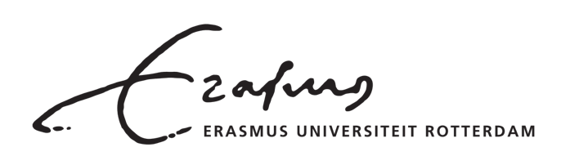

Vision document

Great Place to Grow

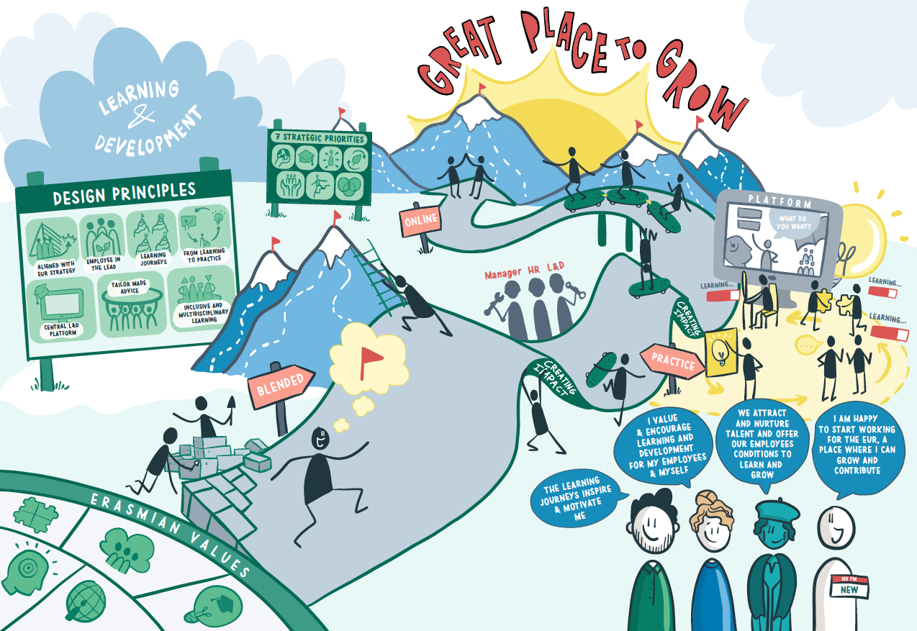

Introduction

At Erasmus University, learning takes centre stage. Not only for students, but also for employees. Learning contributes to an innovative and attractive working environment in which sustainable employability and mobility are essential.

Vision
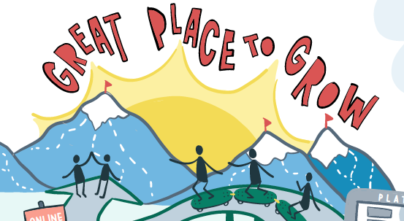
Learning and development are very important, both for the organisation and for the employee. The EUR wants to invest in you and offer you opportunities to invest in yourself.

Agility

In a rapidly changing environment, adaptability is the most important skill that an organisation's employees should have. Adaptability is the ability to tie in with what a new situation requires of the organisation. It allows you to achieve growth, productivity, quality and change. Learning and development increase this ability.

Impact, sustainable employability and mobility

Building professionalism and quality is a prerequisite for achieving social impact. In order to ensure sustainable employability, the EUR offers opportunities for you to further develop your knowledge and skills. This will keep you fit for the future.

Strategy

Offering the right development interventions and aligning them with the organisational objectives makes it possible to steer the development of the entire organisation. Learning and development connects people from an inclusive and interdisciplinary perspective, offering scope for them to get inspired, pursue goals and make an impact together.

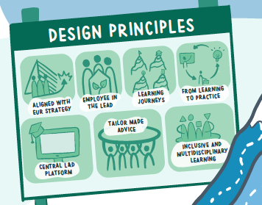
Learning principles

Seven learning principles have been formulated for the way in which we learn and develop within the EUR:

- Learning & development efforts align with the organisational goals and EUR strategy

- You are in the lead, the supervisor helps to steer the course and HR facilitates

- Inspiring examples of learning journeys help you to steer your development

- The range ensures a good learning outcome and the application of what you have learned in practice

- One central platform (website) for learning and development

- You can make independent use of the training opportunities as an employee, while L&D advisers offer tailor-made advice

- The range complies with our Diversity & Inclusion policy and stimulates connection

Safe learning environment

In order to create a ‘Great Place to Grow’, a learning culture and a safe learning environment are essential. In a learning culture, employees learn with and from each other and there is scope to develop and innovate. This requires a safe learning environment in which people can speak openly about ambitions and development, and in which they are allowed to make mistakes and show vulnerabilities.

