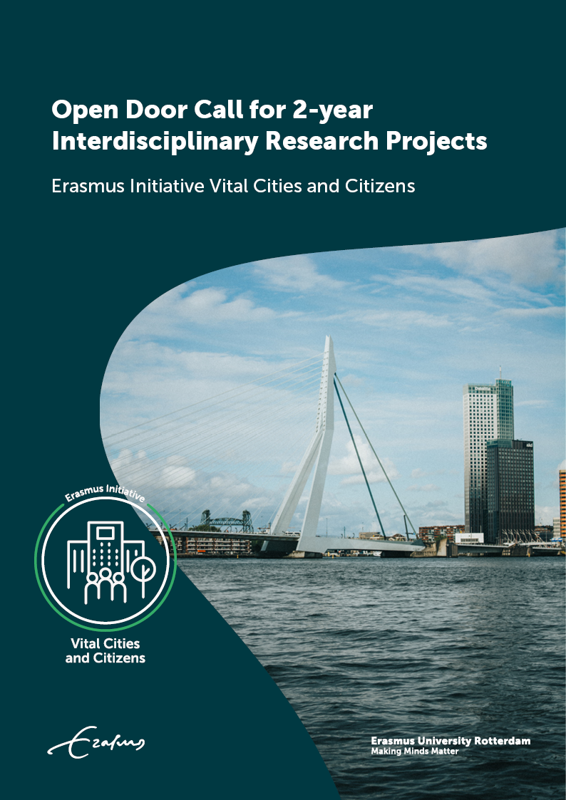
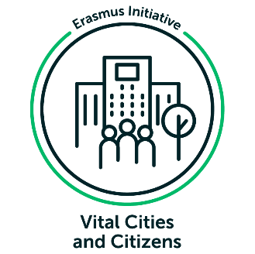
Erasmus Initiative Vital Cities and Citizens
Open Door Call for 2-year Interdisciplinary Research Projects

Background and submission information

Submission deadline:
31 March 2022, at 14.00 p.m.

Contents
1. Introduction 4
1.1. Background 4
1.2. Aim of the call 5
2. ELIGIBILITY CRITERIA 6
2.1. Projects 6
2.2. Consortium/project team 6
2.3. Project timeline and budget 6
3. EVALUATION CRITERIA 7
4. PROCEDURE AND TIMELINE 8
4.1. Procedure 8
4.2. Timeline 8
4.3. Contact 8

Appendix: proposal template 9

- Introduction
The aim of this Vital Cities and Citizens (VCC) Open Door Call for 2-year Interdisciplinary Research is to stimulate interdisciplinary research with positive societal impact that is aligned with at least two of the four core themes of VCC: resiliency, inclusivity, smartness and just sustainability. The objective of the call is to foster interdisciplinary and interfaculty cooperation on research and impact. The explicit aim is that two or more themes are cross fertilized in innovative and inspiring ways. In total, an amount of 1.2M euro is available for this call.

1.1 Background
Vital Cities and Citizens (VCC) is an Erasmus Initiative to stimulate interdisciplinary research with positive societal impact. With this Open Door Call we invite all faculties, schools and institutes of Erasmus University Rotterdam to apply for new interdisciplinary (post-doc) research projects. It is imperative that in the drafted proposals a kind of interfaculty/disciplinary cooperation is developed. It is also possible to include other universities in the application, but it is imperative that a school or institute from Erasmus University is main applicant of the project proposal.
VCC’s main mission statement is to advance our understanding of the ways in which social and cultural transformations affect quality of life in cities, and help cities to thrive as inclusive, resilient, smart and sustainable places in which residents can thrive, live, grow up and work in.
In the research, impact and education program, VCC uses the perspective of urban vitalism not only to elucidate the urban experience from the perspectives and agency of residents. This perspective allows to approach cities and their residents as a relational endeavour, involving social processes through which ways of thinking, valuing and acting are actively constructed by people who live in the city. The city as lived is always in the process of becoming, a process that is dynamic, plural, fluid and relational. This is because it is constantly produced and experienced by people, communities and institutions.
VCC explicitly has the ambition to stimulate and develop interdisciplinary research among different schools, faculties and institutes. Moreover, VCC want to create positive societal impact on society, implying that researchers should develop approaches to include and reach society and to become engaged scholars.
VCC has four core themes. These four sub-themes are:

Inclusive Cities and Diversity
In cities across the world, power and resources are unevenly distributed. Differences linked to class, gender, age, sexual orientation, race, and ethnicity have important consequences for people’s everyday experiences in and with the city. These differences ultimately shape people’s sense of belonging. They also encourage everyday practices that reproduce and/or challenge inequalities. What roles do citizens, policymakers, public officials, activists, businesses, and the media play in these efforts to negotiate diversity? How do they interact with each other and what are the resulting spatial, economic and social forms of in- and exclusion? How and why are these forms of in- and exclusion linked to specific urban settings and how do they fit (or not) within larger national and transnational contexts?

Resilient Cities and People
Many people in cities struggle in facing the constant changes as well as current conditions that exist in large urban areas. The sub-theme Resilient Cities and People concerns the relationship between urban resilience and urban governance considered from the perspectives, initiatives and experiences of urban residents. Central questions are: How do people deal with these challenges? Who ‘makes’ the city and why, when and where? All this is brought into view through the lens of the ‘makeshift city’ which aims to capture how collective and individual people respond to and cope with (e.g. individual resiliency) threat, conflict and opportunities to transform (bounce forward). The aim of this sub-theme is to encourage multi-stakeholder responses to urban crises that start from rather than work against people’s initiatives.

Smart Cities and Communities
Internet of Things (IoT) applications and Big Data analytics are increasingly used by (local) governments and businesses to make decisions in and about cities and communities. The development and use of such ‘smart’ urban technologies comes with some great promises and expectations. For example, they can be used to monitor or measure urban pollution, traffic jams, waste, and are said to enable great innovations in tailoring public services and spaces to the needs of individuals. At the same time, the use of smart urban technologies raises crucial questions about its ethics, economy and politics. What are the consequences of municipalities working closely with commercial technology companies rolling out smart technologies? Are communities involved in decision-making on their ‘smart city’? And (how) do smart urban technologies solve or reinforce social inequalities?

Sustainable and Just Cities.
Sustainable cities are about upholding social justice, ecological resilience and economic vitality for current and future generations. Many social movements and organizations across the world, including activists, entrepreneurs, researchers, policy makers and other citizen, are collaborating to create more sustainable and just cities. They are striving for access to basic needs (e.g. housing, energy, water, food, healthcare), while also respecting future generations and other living creatures. In this sub-theme, we critically engage with these movements through interdisciplinary research. We take complex political interlinkages between ecological, social and economic challenges in urban contexts as a fundamental starting point. What are the challenges and tensions between ecological sustainability and socio-economic justice? How can we ensure that sustainable cities are also just cities? How are people and networks empowered to transform their cities into more sustainable and just environments?

1.2 Aim of the call
The aim of this Vital Cities and Citizens Open Call is to stimulate interdisciplinary post-doc research with positive societal impact that is aligned with at least two of the four core themes of VCC, resiliency, inclusivity, smartness and just sustainability. The explicit aim is that two or more themes are cross fertilized in innovative and inspiring ways.
Grants are meant to elaborate on innovative, out-of-the box ideas: think of new interdisciplinary approaches, methodologies and theories in order to generate encompassing insights and understandings, explaining the vitality of cities and citizens.
The call provides an opportunity to start post-doc projects of two years, starting no later than 1 September 2022.

- Eligibility criteria

2.1 Projects
Project proposals are considered eligible when they meet the following criteria:
- Generate new interdisciplinary collaboration and communities across faculties on the research idea
- Focus on new, innovative ideas on post-doc research
- Aiming at creating positive impact on society
- Include external governmental, public and/or private stakeholders in the project, already at the start of formulating the research idea
- Relate explicitly to at least two of the four core themes of VCC and/or deals with theme crosscutting issues and subjects
- Include (in kind/cash) faculty or external matching of at least 30 percent of the total project value.

The project proposal is written according to the template attached with this document (appendix 1).

2.2 Consortium/project team
Who is this call for?
• senior researchers: (assistant/associate/full) professors and lecturers from Erasmus University should be main applicants. It is possible to have non-EUR scholars and stakeholders take part in the project team as co-applicants.
• at least two different faculties/schools are part of the project team. From every participating knowledge institute, at least 1 department or faculty is represented in the project proposal. The project consortium has one main applicant, who will submit the project proposal.
• at least one external stakeholder/organization (a government agency, societal organization, community-based organization, company, etc.) is part of the project team, for example in the role of monitor, translator to practice, etc.
• the required postdoc is expected to play an important recognizable role in the VCC research program, for example is helping to further elaborating the research community, impact agenda, and quest for new research projects.

2.3 Project timeline and budget
Submitted ‘VCC Open Door projects’ should start no later than September 1st, 2022, and should end ultimately on 31st December 2024. Grants are offered with a maximum of 200,000 euro per project. The total budget of this call is 1.2M euro. This implies that about 6 project proposal will be selected for funding. The VCC funding applies for scientific staff (personal costs) and research costs and material costs. This amount needs to be co-financed with 30 percent.

- Evaluation criteria
Selection of all projects will be done by using the following criteria:

- Excellence and Strategic Fit (40%)
• the project addresses the relevance and fit with VCC objectives and themes.
• The project contributes to at least two of the four VCC themes.
• The project is built on an original and out-of-the box idea and/or uses innovative and unique approaches wherever possible.
• The project explicitly addresses interdisciplinary collaboration across faculties.
• The expected concrete societal impact of the proposal is mentioned.
• The project and project consortium contribute to the development and strengthening of the VCC community.

II. Scientific and societal Impact (30%)
• The project identifies ways to measure its scientific impact.
• The project identifies ways to measure its societal impact.
• The project describes the relevance of external stakeholder involvement in the formulation and implementation of the project.
• The project devotes time and budget for (knowledge) communication and dissemination

- Quality of the project team (20%):
• There is an optimal fit between the aims and objectives of the project, and the expertise of the project team members.
• Collaboration is facilitated within the project in such a way, that optimal use is made of the expertise of all participants.
• The project demonstrates synergies and complementarity of the team.
• The project demonstrates the clear role and dedication of involved personnel in the activities.
• Each participating discipline and external stakeholder fulfil a meaningful role in the project, and this is reflected in the project’s description.

IV. Feasibility of Implementation plan (10%)
• The project work plan is logical, clear and well-defined.
• Sound KPIs are defined. The project ensures that the chosen KPIs, deliverables and outputs fit with the activities’ objectives and timely implementation.
• The milestones that have been chosen are relevant and realistic for the project’s objectives.
• The project include (in kind/cash) faculty or external matching of at least 30 percent of the total project value. So, if you ask for the maximum budget of 200.000 euro funding, 30 percent of this amount of money is covered by 30 percent matching (=60.000 euro maximum) in cash/in kind.

- Procedure and timeline

4.1 Procedure
The publication of the ‘VCC Open Door Call’ is December 8th , 2021. Please submit your proposal according to the template (Appendix 1) to vitalcitiesandcitizens@eur.nl.
The first step in the evaluation procedure, the admissibility of the project proposal, is determined based on the eligibility criteria. If the proposal is not in line with the guidelines, the applicant may resubmit a modified proposal within 48 hours. If the proposal is not adequately corrected, it will not enter the evaluation process. Following this, all submitted project proposals will be evaluated stepwise:
- a selection of projects (six to eight) will be made by an external jury based on the evaluation criteria before 31 May, 2022. The VCC Program Management Teams monitors the selection procedure.
- A formal award letter will be sent to the main project applicant on 1 June, 2022
- Researchers of the selected proposals will be invited to pitch their project during a public event in October 2022 with oral presentations by the main applicants from all selected proposals.

4.2 Timeline
- December 2021, publication of the call
- 31 March 2022 (14.00), deadline of submitting proposal
- 31 May 2022, review and selection of projects
- 15-30 June 2022, formal award letters of selected projects
- 1 September 2022, official start date of the project
- October 2022, pitch of the selected project in VCC Open Doors public event.

  - Contact
For more information, please contact prof.dr. Jurian Edelenbos: edelenbos@essb.eur.nl

Appendix 1: Template and submission form VCC Open Door Call

Title of the proposal

……………………………………………………………………………………………………………………………………………………………….

- Applicants
State the name, affiliation, position, including % of full-time employment, and contact details, of the applicant(s). 2 EUR researchers can apply, one as principal investigator and one co-applicant. It is important that both applicants have different disciplinary/faculty backgrounds.

……………………………………………………………………………………………………………………………………………………………….

- Summary
Give a general summary for laypeople using a maximum of 200 words.

……………………………………………………………………………………………………………………………………………………………….

- Project plan

3.1 Interdisciplinary opportunity
Describe the problem or opportunity for interdisciplinary collaboration. Describe which disciplines and faculties are in which ways involved in the project idea. Also describe carefully how the project idea links to the core themes of VCC. Maximum of 200 words.

……………………………………………………………………………………………………………………………………………………………….

3.2 Milestones and deliverables
Give a clear indication of the step-by-step plan and the intended results of the project. Make sure it is finished by December 31st 2024.
……………………………………………………………………………………………………………………………………………………………….

- Originality and quality

4.1 Uniqueness of the proposal
Address the uniqueness of the research proposal. If current research on the topic or solutions for the problem exist, distinguish between these and the proposal. Make clear how the proposal is the integration of historically distinct disciplines and technologies that creates fundamentally new opportunities for understanding urban life and well-being. Maximum of 250 words

……………………………………………………………………………………………………………………………………………………………….

4.2 Potential impact
Address the potential (scientific, educational or societal) impact the proposal aims to achieve. How is the envisioned contribution of the proposal to impact? Does the proposal aim for direct results, or at eliminating bottlenecks and/or evoking follow up projects or follow up involvement of other staff? Explain how a larger envisioned or actual impact could be achieved. Maximum of 300 words.

……………………………………………………………………………………………………………………………………………………………….

4.3 Quality of the interdisciplinary project team
Address the fit between the aims and objectives of the project, and the expertise of the project team members. Indicate the interdisciplinary/faculty character of the project team. Make clear how collaboration is facilitated within the project in such a way, that optimal use is made of the expertise of all participants. Describe the roles of the team members and the synergies and complementarity of the team. Here explicitly mention the link to and collaboration with external stakeholders, like public, private, societal partners. Explain their role and involvement. It is imperative that the external stakeholders have an active role and say in the creation of the research proposal. Maximum of 300 words.

……………………………………………………………………………………………………………………………………………………………….

4.4 Feasibility
Address the project plan, including milestones, and potential risks. Maximum of 300 words.

……………………………………………………………………………………………………………………………………………………………….

- Financial planning
Clarify expenditures and summarize the amounts in the table below. For personnel indicate type(s) of position(s), duration and (part)time fraction(s). For materials please specify. Use the excel file Financial Planning with the 2021-2022 salary rates. If there are other costs, be specific in the description.
Personnel

Materials

Others (be specific here)

Total

Matching (30 % of
Project value

