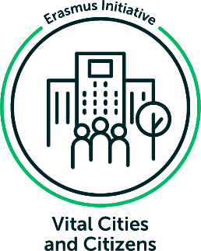
Climate Change Networks and City-to-City Learning
Linking climate change networks and city-to-city-learning to understand under which conditions cities engage with others, by Elena Marie Enseñado

The number of city networks that address climate change issues has increased in recent decades. So has the number of their member cities. In this blog post, the author explores: What is the role of climate change networks as platforms for learning between and among cities? Under which conditions do cities engage in city-to-city (C2C) learning on climate change policies? And, how do climate change networks, C2C learning, and conditions relate?
Climate Change Networks
The number of city networks that address climate change issues, such as the Global Covenant of Mayors for Climate and Energy, Resilient Cities Network, Climate Alliance, or Energy Cities, has increased in recent decades. So has the number of member cities that have become part of these city networks.
Also labelled as climate city networks or transnational climate networks, these entities generally aim to support cooperation between cities in improving their work on climate change adaptation and/or mitigation and other related topics, such as urban resilience and sustainability.
However, these city networks are not homogenous. Recent research points towards the heterogeneity of city networks. They have for example, different organizational structures and governance models, involve different partners and follow different membership in how they attract and engage with member cities.
Why do cities join these climate change networks? Among other reasons, cities gain access to resources, such as funding; build a profile or brand of the city as a climate actor; gain recognition at the international or global levels; and learn from other cities’ experiences.
These networks provide multiple roles– from target setting, project funding, benchmarking, and certification to communication, dissemination, networking, and lobbying . In this blog post, specific attention is given to the role of networks as platforms for city-to-city or C2C learning.
City to City Learning
C2C learning has been described as a process of (mutual) learning between and among cities and their representatives e.g., mayors, civil servants, and political parties. When looking at literature on C2C learning, this is characterized as a dynamic, iterative, and multidirectional process that is pursued with a desired outcome in mind e.g., improved service delivery.
Further, C2C learning is often linked to related concepts, such as policy diffusion, policy transfer, and policy mobility. This link can be explained by the need to understand how certain policies get diffused across cities, how these get transferred from one city to another, and how these mutate through varying networks.
Policy diffusion is “a process in which policymaking and policy outcomes in one polity influence policymaking and policy outcomes in other polities" (Blatter, et al., 2021).
Policy transfer, on the other hand, is "the process by which knowledge about policies, administrative arrangements, institutions and ideas in one political system…is used in the development of policies, administrative arrangements, institutions and ideas in another political system” (Dolowitz and Marsh, 2000).
Lastly, policy mobility emphasizes the mobile character of policies that continuously mutate and transform, depending on context-specific conditions (Peck, 2011). See Table 1 for the concepts related to C2C learning, including the academic disciplines, main goals, and main thematic areas from Haupt, et al. (2019).
Table 1: C2C learning and related concepts (Haupt, et al., 2019)
 | C2C Learning | Policy Diffusion | Policy Transfer | Policy Mobility
Academic Discipline(s) | Resilience | Political Science, Sociology | Political Science, International Studies | Human Geography, Political Science
Main Goal(s) | Knowledge sharing between cities  Learning and improving together | Examining how policy choices made in one place are influenced by the policy choices made in another place  Identifying diffusion mechanisms | Documenting, explaining the movement of policies between countries  Understanding the restricting or facilitating factors for the transfer process and its relation to policy success or failure | Theorizing how knowledge is mobilized  Understanding how ideas become hegemonic and global
Main Thematic Areas | (Disaster) resilience  Smart cities  Water Use | Public policy | Public policy  Comparative Politics | Entrepreneurial governance  Urban social movements  Gentrification  Policing  Planning and redevelopment

The number of research studies on C2C learning has been growing through the years. More recently, C2C learning processes have been described between South American cities on sustainable urban food systems; between African cities on climate change resilience; and between Rotterdam and Mexico City on multi-functional water squares.
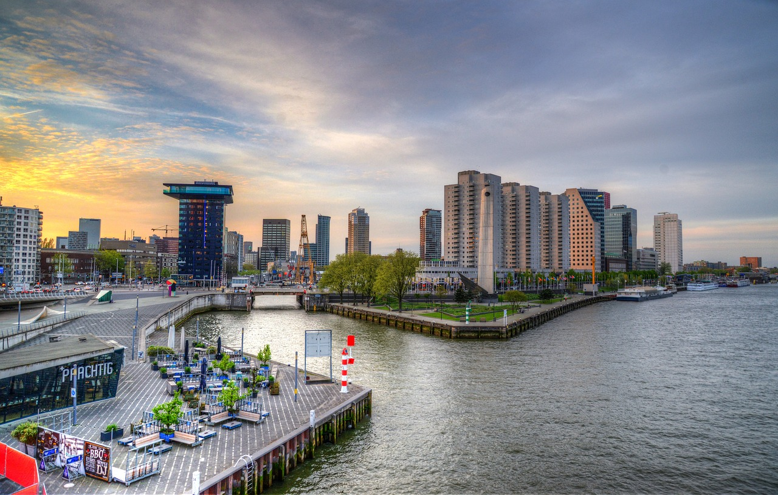
Image: Rotterdam, the Netherlands
Conditions for Engagement
In engaging in C2C learning, different conditions may matter, and the weight may differ depending on city specificities. Therefore, different combinations may determine whether a city decides to engage in C2C learning. Further, some conditions may be sufficient, while others may deem to be necessary.
In C2C learning, exploration has been cited as a first phase, before knowledge of climate change policies are acquired, translated, or utilized. In exploration, cities first assess their own contexts and examine (potential) learning engagements with other cities. This phase is also referred to as information and/or knowledge – seeking and/or sharing.
Whether seeking and/or sharing climate change policy, cities decide to engage in C2C learning – and this can be influenced by networks, among other intermediaries. However, based on existing studies, there are conditions that seem to influence the extent to which cities engage with others on learning about climate change policy.
- Similarity
Cities – and their representatives - seem to be more likely to engage with others who share similarity in geography and language. This has been observed, for example, among cities in Europe and North America. Other similarities that may be important when engaging with other cities include city size, demography, hazards, and related attributes e.g., challenges and impacts.
- Proximity
Cities seem to engage more with their geographical neighbors, and this has been reflected in a recent study in New Zealand. As the distance between cities increases, the likelihood of engaging in C2C learning decreases. Neighbors can have better opportunities to learn with and from each other, considering lower transaction costs in terms of travel, time, and resources that will be incurred.
- Performance
Cities are more likely to engage if the other city has achieved a higher level of climate change policy or performance. For example, these can be in terms of implemented or monitored adaptation or mitigation actions, developed climate change action plans, or greenhouse reduction targets established. Copenhagen, for example, aims to become the world’s first carbon neutral city, making it it destination of sorts for other cities looking for inspiration.
- Centrality
Highly central cities, which are generally developed cities with high performing climate change policies, are more connected and are then more likely to engage. For example, New York and London are highly central cities with more connections and access to other cities – not just from North America or Europe.
- Brokering
Cities that have a multi-stakeholder governing body or advisory committee are more likely to engage with others. This relates to the role of “brokers”, “boundary spanners”, or “bridging organizations” which can connect different actors that are otherwise disconnected and provide opportunities for learning beyond city boundaries. In Europe, for example, there are hundreds of organizations that serve as knowledge centers for sustainable energy and climate actions.
- Leadership
The presence of a leading person or organization that brings people together, creates a vision, facilitates information exchange, or coordinates actions seem to be a necessary condition. Recently, mayors of Yokohama, Despeñaderos, and Menjez joined the Board of the Global Covernant of Mayors for Climate and Energy However, not all cities have top government officials that are responsible for matters related to climate change.
- Previous relationships
Aside from previous relationships between cities – as organizational entities, these can also be between city representatives due to prior transactions, work relocations, as well as interactions at conferences and workshops. Cities tend to search for relevant lessons among trusted partners. This has been evident in two separate studies among cities in China and in New Zealand.
- Willingness to collaborate
Cities need to first assess internally their own contexts, including their strengths and weaknesses, before engaging with others. This was evident in the C2C learning between Rotterdam and Mexico on the topic of multi-functional water squares. Cities’ interest to commit voluntarily in C2C learning is then important. Even with a legislation or mandate that promote C2C learning, it will not be a success without the willingness to collaborate
Linking altogether
In the field of climate change, cities across the globe have been learning with and from each other on various climate change topics – ranging from specific policy ideas and technical solutions e.g., cap and trade systems to methodologies and tools e.g., participatory assessments as well as legislative and administrative developments.
Networks, in general, are regarded, among others, as learning environments (or as spaces where learning happens), process facilitators, or as knowledge brokers. Also, there has been attention towards the role of C2C learning – as facilitated by networks and other intermediaries in the diffusion, transfer, and mobilization of climate change policies.
However, these links need further investigation. While there has been focus on understanding C2C learning processes, including the different phases of e.g., exploration and the mechanisms that activate each one e.g., information seeking and/or sharing, there needs to be more emphasis on the conditions as well as outcomes for C2C learning.
So far, the conditions for engaging in C2C learning, especially in climate change policy, have been studied more broadly. However, are there other conditions aside from similarity, proximity, performance, centrality, brokering, leadership, previous relationships, and willingness to collaborate?
Through further discussions with climate change networks and member cities, the author wishes to continue exploring this topic. Specific questions include with whom do cities engage on C2C learning? How is this influenced by networks? Under which conditions do cities engage with others?
For collaboration, the author can be reached via email at ensenado@ihs.nl.
Reference list
Blatter, J., Portmann, L. and Rausis, F. (2022) “Theorizing Policy Diffusion: From a Patchy Set of Mechanisms to a Paradigmatic Typology,” Journal of European Public Policy, 29(6), pp. 805–825. doi: 10.1080/13501763.2021.1892801.
Bulkeley, H. and Kern, K. (2009) Cities, Europeanization, and multi-level governance: governing climate change through transnational municipal networks. SSRN. Available at: https://ssrn.com/abstract=1331185 (Accessed: May 30, 2023).
Calzada, I. (2020) “Replicating Smart Cities: The City-To-City Learning Programme in the Replicate Ec-H2020-Scc Project,” Smart Cities, 3(3), pp. 978–1003. doi: 10.3390/smartcities3030049.
Cortes, S. et al. (2022) “Unpacking the Heterogeneity of Climate City Networks,” Cities, 121. doi: 10.1016/j.cities.2021.103512.
Dolowitz, D. P. and Marsh, D. (2000) “Learning from Abroad: The Role of Policy Transfer in Contemporary Policymaking,” Governance, 13(1), pp. 5–23. doi: 10.1111/0952-1895.00121.
Elkhidir, E. et al. (2023) “A Pathway Towards Resilient Cities: National Resilience Knowledge Networks,” Cities, 136. doi: 10.1016/j.cities.2023.104243.
Haupt and Coppola (2019) “Climate Governance in Transnational Municipal Networks: Advancing a Potential Agenda for Analysis and Typology,” International Journal of Urban Sustainable Development, 11(2), pp. 123–140. doi: 10.1080/19463138.2019.1583235.
Haupt et al. (2020) “City-To-City Learning Within Climate City Networks: Definition, Significance, and Challenges from a Global Perspective,” International Journal of Urban Sustainable Development, 12(2), pp. 143–159. doi: 10.1080/19463138.2019.1691007.
Heikkinen, M. et al. (2020) “Transnational Municipal Networks and Climate Change Adaptation: A Study of 377 Cities,” Journal of Cleaner Production, 257. doi: 10.1016/j.jclepro.2020.120474.
Heikkinen (2022) “The Role of Network Participation in Climate Change Mitigation: A City-Level Analysis,” International Journal of Urban Sustainable Development, 14(1), pp. 1–14. doi: 10.1080/19463138.2022.2036163.
Helguero, M. L., Steyaert, A. and Dessein, J. (2022) “City-To-City Learning Processes in the Development of Sustainable Urban Food Systems: Insights from South American Cities,” Habitat International, 124. doi: 10.1016/j.habitatint.2022.102578.
Ilgen, S., Sengers, F., and Wardekker, A., (2019) “City-To-City Learning for Urban Resilience: The Case of Water Squares in Rotterdam and Mexico City,” 11(5), pp. 983–983. doi: 10.3390/w11050983.
Lee, T. and Jung, H. Y. (2018) “Mapping City-To-City Networks for Climate Change Action: Geographic Bases, Link Modalities, Functions, and Activity,” Journal of Cleaner Production, 182, pp. 96–104. doi: 10.1016/j.jclepro.2018.02.034.
Lee, T. and van de Meene, S. (2012) “Who Teaches and Who Learns? Policy Learning through the C40 Cities Climate Network,” Policy Sciences, 45(3), pp. 199–220
Moodley, S. (2019) “Defining City-To-City Learning in Southern Africa: Exploring Practitioner Sensitivities in the Knowledge Transfer Process,” Habitat International, 85, pp. 34–40. doi: 10.1016/j.habitatint.2019.02.004.
Moodley, S. (2020) “Exploring the Mechanics of City-To-City Learning in Urban Strategic Planning: Insights from Southern Africa,” 2(1). Doi: 10.1016/j.ssaho.2020.100027.
Peck, J. (2011) “Geographies of Policy: From Transfer-Diffusion to Mobility-Mutation,” Progress in Human Geography, 35(6), pp. 773–797.
Woodruff, S. C. (2018) “City Membership in Climate Change Adaptation Networks,” Environmental Science and Policy, 84, pp. 60–68. doi: 10.1016/j.envsci.2018.03.002.
About the author
Elena Marie Enseñado (ensenado@ihs.nl) works as an urban environment, sustainability, and climate change specialist at the Institute for Housing and Urban Development Studies (IHS), Erasmus University Rotterdam.

See Cortes, et al. (2022); Heikkinen, et al. (2020); and Haupt and Coppola (2019).
See Cortes, et al. (2022); Haupt and Coppola (2019); and Lee and Jung (2018).
See Heikkinen, et al. (2020); and Haupt, et al. (2019).
See Haupt, et al. (2019); Kern and Bulkeley (2009).
See Haupt, et al. (2020); Calzada (2020); and Moodley (2019).
See Helguero, et al. (2022); Moodley (2020); and Ilgen, et al. (2019).
See Lee and Van de Meene, 2012
See Elkhidir, et al., 2023

